The LNM Institute of Information Technology, Jaipur Mid-Semester Examination I, Autumn Semester (2014-15) Control System Engineering (ECE 327)

Time: 1 Hr. M.M.: 20

- For a system with the block diagram shown below, the closed-loop transfer function is most sensitive to changes in which block component? Write the name of the block only. [1]

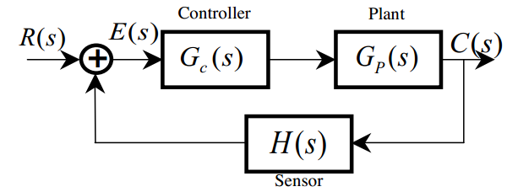
- A system is described by the following differential equation with the initial conditions

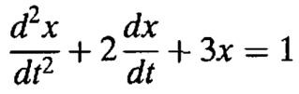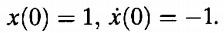
Show a block diagram of the system, giving its transfer function and all pertinent inputs and outputs.
[4]
- For the controlled system with control and plant shown below,

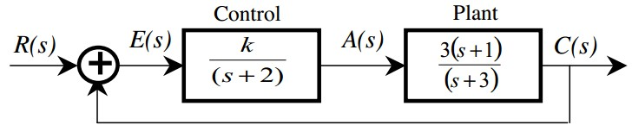
  - Find the closed-loop system’s characteristic polynomial?
  - Find is the closed-loop error transfer function, E(s)/R(s)? [5]

- For the block diagram given below, find the system transfer function C(s)/R(s). Simplify as much as possible and express the result as the ratio of two polynomials. [4]

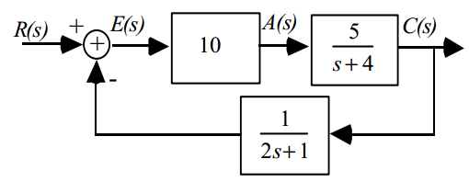
- Given the block diagram of a system shown in Figure below, find the transfer function G(s)=Ɵ22(s)/
Ɵ11(s). [6]

